**CLATT SCHOOL**

Anti-Bullying

Policy

February 2018

Written by Barbara Rae



Clatt Primary School

Anti-Bullying Policy

February 2018

**CLATT PRIMARY SCHOOL VISION**

At Clatt School we aim to create an environment where:

* All members of the school community develop confidence through an ethos of high aspirations and expectations
* Learning is highly valued amongst all members of the school community
* Co-operation enables us to share, celebrate and enhance individual strengths and abilities
* A climate of responsibility and mutual respect ensures that all members of the school and wider community are valued and pupils play their part in society
* Every child is nurtured to reach their full potential and have the skills and confidence to become:

***Responsible Citizens***

***Effective Contributors***

***Successful Learners***

***Confident Individuals***

**CLATT PRIMARY SCHOOL VALUES**

**R**esponsible **E**thos **S**upportive **P**olite **E**nthusiastic **C**aring **T**ry your best

“All children have a right to relax and play and to join in a wide range of activities”

(UNCRC United Nations Convention on the Rights of the child) Article 31)

At Clatt Primary we believe that pupils should be protected from any behaviour by others that makes their lives difficult or causes them stress.

Bullying at school can have a profound effect on pupils. It can undermine their self-esteem and self-confidence and can result in victims of bullying becoming bullies themselves. The Anti-Bullying policy has been drawn up within the school’s ethos of promoting positive behaviour.

**AIMS:**

The aim of this policy is:

* To define bullying
* To set out actions which will be taken against bullying
* To encourage active parental support in achieving our aims.

**OBJECTIVES:**

* To reduce the instances and incidents of bullying.
* To make pupils, staff and parents aware of the anti–bullying policy and their overall responsibilities within it.

**What is Bullying?**

Bullying is repeated aggressive behaviour which hurts, frightens or causes unhappiness to another.

**This behaviour includes:**

* Name calling
* Hitting, kicking, punching
* Damaging or stealing property
* ‘Ganging up’ on people
* Teasing about personal or physical differences
* Teasing about family/domestic/cultural situations
* Threatening
* Shouting, swearing, verbally abusing
* Extorting
* Malicious gossiping
* Forcing someone to do something they do not wish to do
* Isolating someone
* Sending offensive/threatening texts, e-mails or social media communication

**What actions will be taken against bullying?**

At Clatt Primary, we teach the pupils Clatt Values which are:

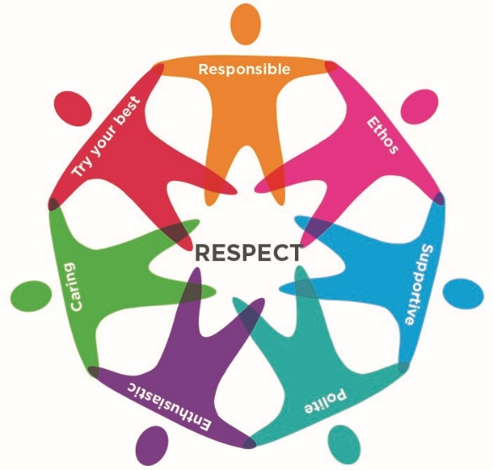

We teach these values through all curricular areas and expect the children to adhere to them.

Bullying is often discussed in class and features in our school assemblies.

As part of the school’s strategy for promoting positive behaviour, we look at attitudes, skills and activities which will prevent bullying:

* We value and listen to children’s contributions
* We help the children learn and practice the skills required to build good relationships with other children and adults within the school and the wider community
* We provide strategies for dealing effectively with bullies
* We have a restorative approach to dealing with problems

**Raising Pupil Awareness:**

Activities through which this can be developed:

* Games
* Stories, poems, media
* Poster campaigns
* Written work
* Behaviour - problem solving scenarios
* Circle Time/Pupil Voice
* School assemblies
* Peer mediation

As a Rights Respecting School, children are taught about their rights and the importance of respecting the rights of others.

**Practical Advice to Share with Pupils:**

* **Tell** an adult (Member of staff or a parent) or a friend.
* **Understand that the problem needs to be discussed – to be solved**

**Practical Advice for Parents:**

* Encourage your child to talk about what has happened in school and talk through any incidents calmly.
* If you are concerned, contact the school immediately so that the matter can be investigated.
* Watch out for signs of stress in your child such as headaches, sore stomachs, reluctance to come to school. These can be indications that all is not well.

**Raising Teacher Awareness:**

Signs which may indicate bullying:

The child may:

* Be unwilling to come to school
* Begin to do poorly in school work
* Become withdrawn
* Start acting out of character, by for example hitting other children
* Develop stomach aches or headaches
* Want to stay in at break-times
* Have an injury after playtimes

**Advice for PSAs**

* Discourage rough play.
* Be aware of isolated children, and try to involve them in a sympathetic group.
* Report any incidents causing concern to a member of the teaching staff. Persistent bullying **must** be reported to the Head Teacher.
* Try to help children talk though minor incidents - listen to both sides **calmly.**

**How We Deal with Bullying**

We ensure all members of staff are aware of what constitutes bullying.

Staff maintain constant vigilance for signs of bullying in school.

All incidents of bullying are investigated, recorded, discussed and resolved, and the children involved supported. We try, wherever possible, to work in partnership with parents/carers to resolve incidents.

We **investigate** the incident to find out what has happened, we listen to everyone involved and **record** the incident, and action taken, within the school.

We **deal** with the incident if the investigation shows a need for disciplinary action to be taken.

We **support** the victim and work with all concerned to **resolve** the incident.

We **work** with pupils who behave in a way that is threatening or intimidating to others and help them to **manage** their behaviour and relationships.