**CLATT SCHOOL**

Self-Evaluation

Policy

February 2018

Written by Barbara Rae



Clatt Primary School

Self-Evaluation Policy

February 2018

**CLATT PRIMARY SCHOOL VISION**

At Clatt School we aim to create an environment where:

* All members of the school community develop confidence through an ethos of high aspirations and expectations
* Learning is highly valued amongst all members of the school community
* Co-operation enables us to share, celebrate and enhance individual strengths and abilities
* A climate of responsibility and mutual respect ensures that all members of the school and wider community are valued and pupils play their part in society
* Every child is nurtured to reach their full potential and have the skills and confidence to become:

***Responsible Citizens***

***Effective Contributors***

***Successful Learners***

***Confident Individuals***

**CLATT PRIMARY SCHOOL VALUES**

**R**esponsible **E**thos **S**upportive **P**olite **E**nthusiastic **C**aring **T**ry your best

**Rationale**

Effective self-evaluation involves a level of reflection and critical enquiry which is best achieved through a blend of internal and external analysis. Making sound judgements about the impact on learners should be central to self-evaluation.

Collaborative enquiry brings depth to practitioners’ professional learning and leads to more accurate and honest self-evaluation.

Effective on-going self-evaluation provides a unique and valuable picture of what is having most and least impact on learners in a single class, at a stage, within a school or across a cluster or local authority. It should take place within an aspirational vision for continuous school improvement where all stakeholders consider, “How good can we be?” Once the quality of the impact on learners has been evaluated, then plans for improvement can be drawn up. Looking outwards, in other words learning from what happens elsewhere, and looking forwards, in other words exploring what the future might hold for today’s learners, can provide the justification for moving things in a different direction, and the motivation and inspiration that underpins a school’s vision to be the best it can be.

**How Good is Our School? 4th Edition (Education Scotland)**

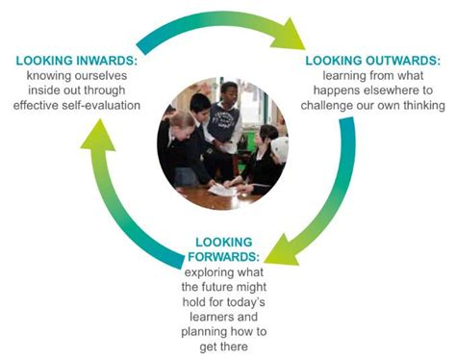

**Self-evaluation** is used to cover the way in which individuals and settings explore their progress, develop and practice to identify what has improved and what still needs to improve. It is a way of using evidence to assess achievements and success and areas that still need action. The significant relationship between effective self-evaluation and improvement might also be understood to help settings answer the familiar three questions, which remain at the heart of self-evaluation:

* How are we doing?
* How do we know?
* What are we doing now?

**How Good is Our Early Learning and Childcare? Feb 2016**

**(Education Scotland)**

**Monitoring is the gathering of information. Self-evaluation is analysing that information.**

Evaluating learning, teaching and assessment and the quality of what goes on in the classroom will tell us how good the experience is for children, as we strive towards excellence for all. We know that for children and young people from the most deprived backgrounds, the gap in learning can develop from a young age. Evaluating school improvement and work with partners will help us to focus on early and sustained intervention and support for children and their families. School inspection, school self-evaluation and local authority reporting on attainment and achievement will tell us how well schools are achieving equity for children. This will include the school’s success at raising attainment for all, whilst closing the gap between the most and least disadvantaged children.

**National Improvement Framework for Scottish Education. January 2016 (Scottish Government)**

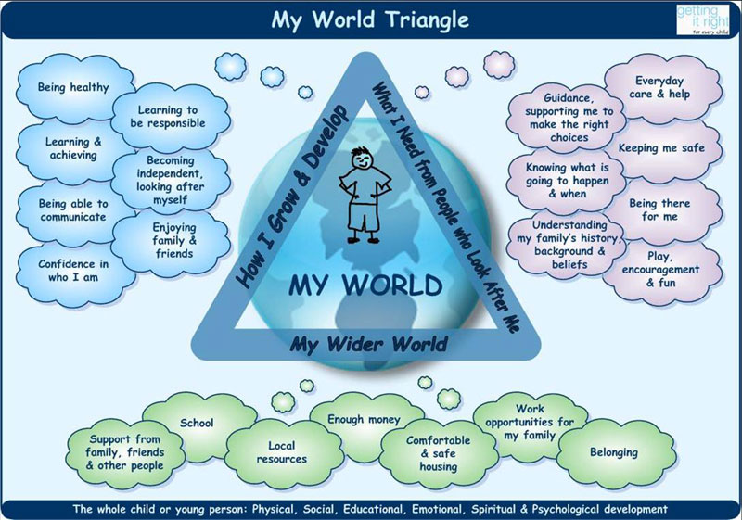

**Clatt Primary School** aims to use monitoring and evaluation as strategies for assessing our school’s success in achieving our ‘values and aims’, and for strengthening our capacity for improvement.

We monitor and evaluate the quality and standards in the school to ensure that we are providing the best education possible for the children in our care and are constantly seeking to improve.

It is important that all members of staff should be aware of the nature and scope of monitoring activities undertaken in the school and the implications for them in their work. These activities are primarily concerned with whole school improvement and not individual accountability.

**What is monitored?**

There are a number of areas such as pupil achievement, attendance, complaints and finance, which are monitored on a regular basis. Other areas are monitored when they feature as improvement priorities or areas of particular concern. In order to manage this process we focus on some areas annually, termly, monthly, weekly or daily as part of our Self-evaluation Calendar, Reporting Calendar and School Improvement Plan.

**We monitor:**

* Attendance
* Child Protection
* GIRFEC
* Behaviour
* Compliments/concerns
* School Improvement Plan
* Budgets
* Curriculum design
* Curriculum Assessment results
* Standardised Assessment results
* Learning and Teaching
* Jotters
* Surfaced learning – displays of work
* Use of Pupil Support Assistants
* Achievements in and out of school
* Termly, weekly and daily plans
* Recording
* Resources
* New initiatives
* Community involvement
* Pupil Council
* Outdoor learning
* Health and Wellbeing
* Transition
* Enterprises
* Use of ICT and Digital Learning

**Roles and Responsibilities**

The **Head Teacher** has the overall responsibility for monitoring the work of the school.

The **teaching staff** have responsibility for monitoring planning and outcomes, for the learning through both summative and formative and standardised assessment, and for asking children about their learning. These are generally just for the use of the teacher to develop learning and teaching in class but may be used for school improvement.

**Pupil Support Assistants** can be asked to monitor children’s responses in class, the children’s application to learning, behaviour and anything the teacher requires of them to aid the learning and teaching on any day.

**The administrator** monitors day to day attendance and punctuality, return slips, accidents, medicines, payments, spending and budgets.

**We self-evaluate through:**

* Teacher’s planning folders for each stage – clarity, robustness, progression, differentiation
* Collegiate discussions
* Classroom/lesson observations (formal and informal) by HT and peers
* Jotter monitoring
* Formal reports
* I.E.P’s
* Assessment results – formative, summative and standardised
* Stakeholders’ views – questionnaires, parents evenings, reviews, MAAP’s etc.
* HMIe inspection recommendations and implementation – last inspection June 2014
* Evaluating resources
* External and internal environment
* Whole staff meetings and one to one
* PDRS, EDRS and GTC record of CPD
* Achievements throughout school (on displays)
* Pupil Council responsibilities and ideas
* Parent council views and expectations
* Tracking folders
* Course attendance and outcome/impact – staff discussion
* Home/school communication – home/school diary, reporting to parents process, newsletters, showcases
* Pupil attitudes and behaviour
* Assessment folders
* Pupil Profile folders
* Termly jotters

**KEEPING EVIDENCE**

Teaching staff will be responsible for keeping assessment folders/portfolios up to date. Each child will have a folder which will contain assessments in Literacy, Numeracy, Health and wellbeing and other curricular areas. Folders will be kept chronologically to show progression.

The HT will update the electronic tracking system.

Photos and videos will also be kept to evidence progression, attainment and achievement.

**MONORTING AND SELF EVAVLUATION PLANNING**

The HT compiles a self-evaluation calendar which is distributed to all staff. Members of the Parent Council are invited to either read it or have a copy.

As reporting to parents and carers is crucial to school evaluation, a calendar of reporting will be displayed in the staffroom and shared with parents.

Both calendars feed into our Improvement Plan and will be continually evaluated at staff meetings throughout the year to ensure that we meet the priorities detailed in the Improvement Plan.

**CONCLUSION**

We at Clatt School believe that the culture of reflection and planning for improvement through monitoring and self-evaluation is essential in ensuring our values and aims are met, and what we do has the most positive impact on all the children in our care.

Signed __________________________ Date_____________